Ministry of Science and Higher Education of the Russian Federation
FSBEI HE Irkutsk National Research Technical University

V Baikal International Scientific Conference - Strategy Session on

«Snow Cover, Atmospheric Precipitation, Aerosols»
June 19 – 23, 2023

FIRST ANNOUNCEMENT

Irkutsk city (Listvyanka Village, Lake Baikal, 63 km away from Irkutsk)

Irkutsk National Research Technical University holds the V Baikal International Scientific Conference - Strategy Session on «Snow Cover, Atmospheric Precipitation, Aerosols» from June 19th to 23rd, 2023 at Listvyanka Village, Lake Baikal.
Scientific Conference - Strategy Session is held to bring together representatives of stakeholders to analyze and assess the current situation, identify problems, develop solutions and a common vision for the development of research on snow cover, precipitation and aerosols. The conference will contribute to the creation of a new scientific and discussion platform in the Baikal region.
The conference working languages are English and Russian.

Focus Sessions

- Methods, tools and research methodology of the physical and chemical properties and the composition of the snow cover, precipitations and aerosols.
- Impact of the climate change, physical and chemical processes in atmosphere and anthropogenic activities on the chemical composition of the snow cover, atmospheric precipitations and aerosols.
- Modeling and research of the climate change, the physical properties and the chemical composition of the snow cover, atmospheric precipitations and aerosols.
- Role of the snow cover, atmospheric precipitations, and aerosols in the biogeochemical cycles and the cryosphere.
- Interaction of oceans, land surface and biosphere with the snow cover, atmospheric precipitations and aerosols.
- Assessment of the impact of the snow cover, atmospheric precipitations, and aerosols on the natural and socioeconomic systems and on the human health.
- Snow cover, precipitations and aerosols in philosophy, history of science and arts.
- Information technologies in research of the snow cover, precipitations and aerosols.

Conference location and accommodation of participants

The opening ceremony of the conference will take place at INRTU on June 19, 2023. The conference will be held on June 19-23, 2023 in Mayak hotel in Listvyanka village, located on the shore of Lake Baikal (http://www.mayakhotel.ru/).
Participants make their own hotel reservations through the hotel website (http://www.mayakhotel.ru/), with a pre-approved 15% discount (through the hotel website directly or by calling the hotel). It is possible to stay in other hotels of Listvyanka village; the participants book rooms by themselves.

Important Dates

March 1, 2023 – May 15, 2023 – registration, speakers with oral presentations have to submit the materials for publication including the mandatory provision of expert opinions on the website http://snow-baikal.tw1.ru/ or via email snowrainbaikal23@gmail.com.
March 1, 2023 – May 15, 2023 – registration, participants without reports or with online reports via the website http://snow-baikal.tw1.ru/, deadlines are due to the program preparing and disseminating.
May 15, 2023 – registration fee payment deadline

Payment Details
Address: 83, Lermontov St. Irkutsk city, 664074, Russia
Federal State Budget Educational Institution of Higher Education “Irkutsk National Research Technical University”: Irkutsk Regional Fiscal Department (FSBEI HE INRTU, personal account 20346Х10750)
Individual Taxpayer Number 3812014066
Registration Cause Code 381201001
Beneficiary bank: Irkutsk Branch of the Bank of Russia // Irkutsk Regional Fiscal Department Irkutsk
Current account 03214643000000013400 (Treasury account of the Office)
Correspondent account 40102810145370000026 (Single Treasury Account of the Office)
Bank Identification Code 012520101
Code of All-Russian Classificatory 02068249
State Registration Number 1023801756120
All-Russian Classifier of Territories of Municipal Entities 25701000
Budget Classification Code 000 000 00 00 000 0000 130.

June 19-23, 2023 – the Conference sessions.

Requirements for participation, the amount of the organizational fee*

Participant, full-time participation, with publication - 20 000 rubles.
Participant, correspondence participation, with publication – 2 000 rubles.
Online participant, with publication – 2 900 rubles.
Participant, full-time participation, without publication – 18 000 rubles. The registration fee includes 20% VAT and 10% INRTU services; accommodation fee for full-time participants is not included. The conference is held only at the expense of registration fees of the participants.
- Conditions of participation and fees for non-budgetary organizations should be specified in the Organizing Committee
Proceedings of the Conference

Publication materials are accepted either in Russian or in English in Docx format (Annex 1). Please follow the link http://snow-baikal.tw1.ru/ to find the sample and publication requirements of the materials. The authors from the Russian Federation and from the Commonwealth of Independent States (CIS) should provide an expert evaluation of the possibility to publish the article in the open access in PDF format. The authors assume obligations to provide the final, revised version of the article, with reliable information, no conflict of interest.
All the materials will be peer-reviewed before publication.
To submit the materials for the conference upon registration via the conference website (http://snow-baikal.tw1.ru) or email snowrainbaikal23@gmail.com (contact person for website issues: Vadim Leonidovich Arshinskii +79149371595). Please make sure that you have received the materials. Registration through the website is necessary, because all the correspondence will be sent to your data registered.
The Conference Proceedings will be published before the start of the Conference; the publications will be presented on eLIBRARY.RU and included to scientometric Russian database RSCI.

Contact Information

For possible changes, please, check information via the website of the conference or contact us via e-mail: snowrainbaikal23@gmail.com or telephone numbers: +79501018946 – Natalia Ivanovna Ianchenko (scientific program), +79149426951 – Igor Anatolyevich Ognev (general matters).
ANNEX 1

REPORT TEMPLATE
The title of the report, authors' names, and names of organizations, summary and key words must be first in Russian, then in English. Then the text of the report is either only in Russian or in English. Materials are published in author's edition.

НАЗВАНИЕДОКЛАДА (шрифт полужирный, 14 пт, прописные)
(пропуск строки)

Иванов А.А.¹, Власов Б.Б.² (шрифт полужирный,14 пт)
(пропуск строки)
¹ Лимнологический институт СО РАН, Иркутск, Россия
² Иркутский национальный исследовательский технический университет, Иркутск, Россия
(электронный адрес) ivanov@mail.ru
(пропуск строки)
Аннотация. Не более 100 слов. Шрифт – Times New Roman. Высота шрифта – 12 пт.
(пропуск строки)
Ключевые слова: не больше 5 слов. Шрифт – Times New Roman. Высота шрифта – 12 пт.
(Skipping a line)
PAPER TITLE
(Skipping a line)

Ivanov А.A.¹, Vlasov B.B.²
(Skipping a line)
¹ Limnological Institute SB RAS, Irkutsk, Russia
² National Research Technical University, Irkutsk, Russia
(email) ivanov@mail.ru
(Skipping a line)
Summary. Not more than 100 words. Font - Times New Roman Cyr. Font height – 12 pt.
(Skipping a line)
Key words: not more than 5 words. Font – Times New Roman. Font height – 12 pt.
(Skipping a line)
The report should not exceed 5 pages. The text should be typed using a text editor Microsoft Word, format doc, under the following parameters: paper size – А4 (210×297), margins: 2.5 cm all round, font Times New Roman, size 14, a first paragraph – 1.25 cm, single spacing, full justification.
Pictures, diagrams, and photographs are placed directly in the text. Pictures can only be in black and white. Pictures and diagrams should have a minimum of alphabetic and numeric designations. Necessary text explanations are given in the form of captions. The number and title should be placed under the picture.
(Skipping a line)
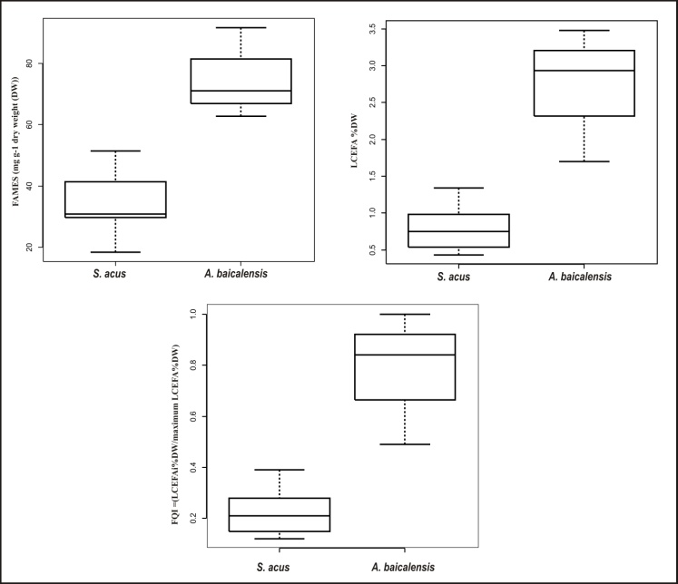
Figure 1: Distribution of fatty acid parameters in tests (boldface, 12 pt)
(Skipping a line)
Tables placed in the text of the report and print font - Times New Roman. Font height - 12 pt, interval - single. The table number and name should be placed above the table.
(Skipping a line)
Table 1. Table name (bold font, 12 pt)
(Skipping a line)
Formulas must be placed through the formula editor, numbered; a reference to the formula number should be given throughout the text.
Numeration of the list of references is carried out as they are cited (by the first citation).
Throughout the article, numbers in square brackets gives bibliographic references: [1], [2], [3], [4, 5].
Not more than 10 sources allowed in the list of references as they occur in the text.
(Skipping a line)

